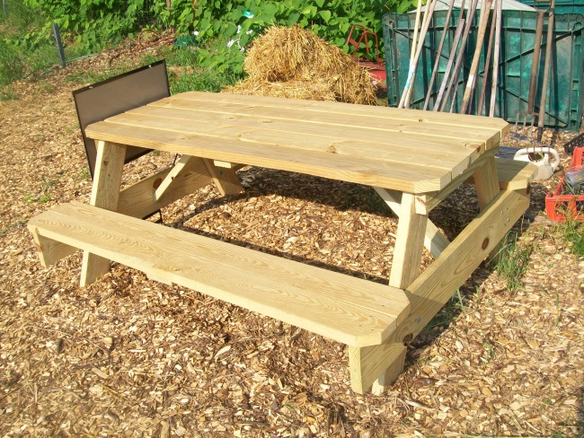

**MEET THE GARDEN INTERNS:**

**Samm Jensen** is from Muskegon, MI and will enter her last year

of studying Psychology at

Geneva College in the fall.

Samm is living in City House

for the summer while she

works at the Tiger Pause

summer camp and with

the community garden.

**Anna Wargo** is from Ypsilanti, MI and lives with her husband Glenn in Beaver Falls. She has studied middle school social

studies education at Geneva for four years, and will have her last semester of student teaching in the fall.

*We’d love to talk with you to get to know you! We also would love to hear any ideas that you have for the community garden.*

Our garden has exploded with growth! You can expect to receive radishes and lots of greens in your share the next few weeks: spinach, kale, Swiss chard, lettuce, and mesclun mix (baby kale, arugula… the fancier and bitterer salad greens). We have a lot to look forward to later in the summer: tomatoes, zucchini, cucumbers, green peppers, carrots, potatoes, onions, basil, celery, beets, and cabbage.

We are looking for volunteers to water on Friday and Saturday mornings (about a one hour commitment). Sign up for one or a few days to water, and we will plan a time to show you our system for watering. Sign up on Monday nights, or email us and pick a date!

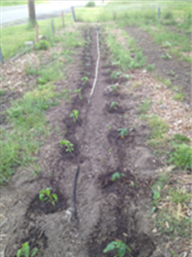

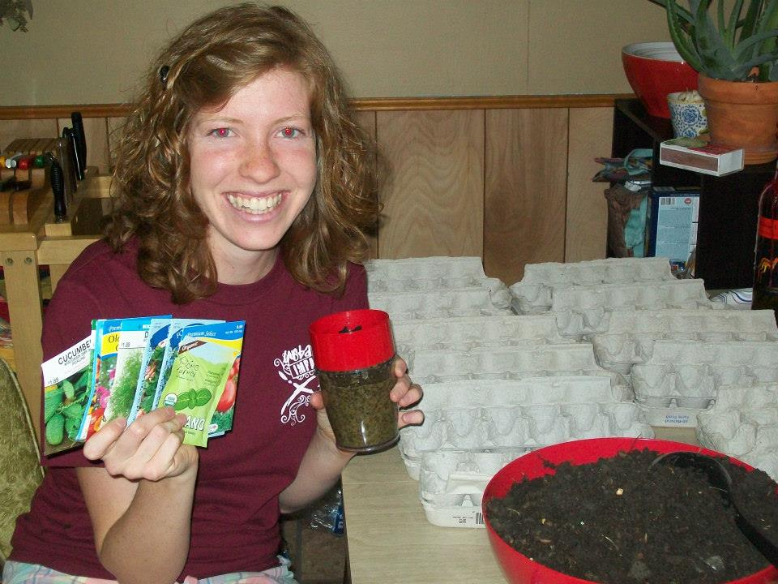

**HOW TO CREATE YUMMY SALADS:**

1. Use a mix of your greens from the garden—too much lettuce is boring, but too much arugula is bitter.
2. Chop up some toppings: get creative! Add some radish for a bit of spice, try adding berries or citrus, fresh veggies, bacon bits, cheese, nuts…
3. Make a delicious dressing:

***find more recipes on the website!

**LEMON VINAIGRETTE**

Whisk together:

1 tablespoon lemon juice

1/2 teaspoon Dijon mustard

1/4 teaspoon sugar

2 tablespoons olive oil

**AVOCADO DRESSING**

Blend:

1 small avocado (peeled, pitted)

1 cup fresh orange juice

1/2 cup lemon or lime juice

2 green onions

1/2 tsp salt

Pinch of pepper and a pinch of sugar